Parametric equations 15-12-21

Question 1
[Edexcel C4 Jan 2010 Q7a]

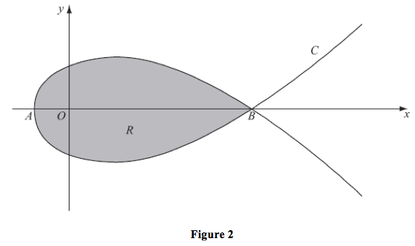
$x=5t^{2}-4$, $y=t\left(9-t^{2}\right)$
The curve C cuts the $x$-axis at the points $A$and $B$.
Find the $x$-coordinate at the point $A$and the $x$-coordinate at the point $B$.
Correct answer:
x=-4 or x=41
Their answer:
x=-4 or x=41
(3 marks)

Question 2
The curve $C$ has parametric equations
x=t+7, $y=t^{2}-5$, $t∈ℝ$
Find a Cartesian equation for the curve $C$.
Correct answer:
y=x-72-5
Their answer:
$y=x^{2}-14x+44$

Question 3
The curve $C$ has parametric equations
x=10t, y=3t+1, $t∈ℝ$
Find a Cartesian equation for the curve $C$.
Correct answer:
$y=3\left(\frac{x}{10}\right)+1$
Their answer:
$y=\frac{3}{10}x+1$

Question 6
[Edexcel A2 Specimen Papers P2 Q10a]
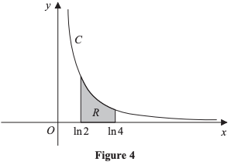
Figure 4 shows a sketch of the curve $C$ with parametric equations
x= ln t+2,y=1t+1,t>-23
State the domain of values of $x$ for the curve $C$.
Input note: use exact values.
Correct answer:
$x> ln \left(\frac{4}{3}\right)$
Their answer:
$x> ln \left(\frac{4}{3}\right)$
(1 mark)

Question 8
The curve $C$ has parametric equations
x=2t, $y=t^{2}-5$, $t∈ℝ$
Find a Cartesian equation for the curve $C$.
Correct answer:
$y={\left(\frac{x}{2}\right)}^{2}-5$
Their answer:
$y=\frac{x^{2}}{4}-5$

Question 4
The curve $C$ has parametric equations
x=t-5, $y=t^{2}$, $t∈ℝ$
Find a Cartesian equation for the curve $C$.
Correct answer:
y=x+52
Their answer:
$y=x^{2}+10x+25$

Question 5
[Edexcel C4 June 2014 Q5a Edited]
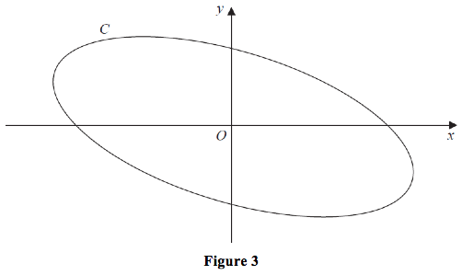
Figure 3 shows a sketch of the curve C with parametric equations
$x=4 cos \left(t+\frac{π}{6}\right)$, y=2 sin t, 0≤t≤2π
Show that
x+y=A cos t
where $A$ is an exact constant to be determined.
Correct answer:
$A=2\sqrt{3}$
Their answer:
$2\sqrt{3}$
(3 marks)

Question 7
[Edexcel C4 June 2014(R) Q8a]
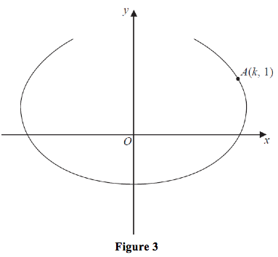
The curve shown in Figure 3 has parametric equations
x=t-4 sin t, y=1-2 cos t, -2π3≤t≤2π3
The point $A$, with coordinates k,1, lies on the curve.
Given that k>0, find the exact value of $k$.
Correct answer:
$k=4-\frac{π}{2}$
Their answer:
$4-\frac{π}{2}$
(2 marks)

Question 9
The curve $C$ has parametric equations
x=2t, y=5t-3, $t∈ℝ$
Find a Cartesian equation for the curve $C$.
Correct answer:
$y=5\left(\frac{x}{2}\right)-3$
Their answer:
$y=\frac{5}{2}t-3$

Question 10
The curve $C$ has parametric equations
$x=\cos^{2}t$, $y=5\sin^{2}t$, 0≤t≤2π
Find a Cartesian equation for the curve $C$.
Correct answer:
$x+\frac{y}{5}=1$
Their answer:
y=5-5x

Question 11
[SQA Advanced Higher Maths 2017]
A beam of light passes through the points B7,8,1 and T-3,-22,6.
Obtain parametric equations of the line representing the beam of light.
Correct answer:
x=2λ-3, y=6λ-22, z=6-λ
Their answer:
x=2λ+7, y=6λ+8, z=-λ+1

Question 12
The curve $C$ has parametric equations
x=t+1, y=3-2t, $t∈ℝ$
Find a Cartesian equation for the curve $C$.
Correct answer:
y=3-2x-1
Their answer:
y=5-2x

Question 13
[Edexcel C4 Jan 2013 Q5d Edited]
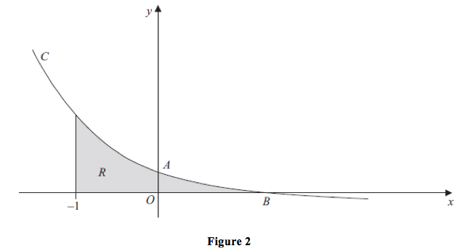
Figure 2 shows a sketch of part of the curve C with parametric equations
$x=1-\frac{1}{2}t$, $y=2^{t}-1$.
The curve crosses the $y$-axis at the point $A$ and crosses the $x$-axis at the point $B$.
The point $A$ has coordinates 0,3 and the point $B$ has coordinates 1,0.
The region R, as shown shaded in Figure 2, is bounded by the curve C, the line x=-1 and the $x$-axis.
Use integration to find the exact area of R.
Correct answer:
152 ln 2-2
Their answer:
$\frac{15}{2 ln \left(2\right)}-2$
(6 marks)

Question 14
The curve $C$ has parametric equations
x=7t, $y=t^{2}$, $t∈ℝ$
Find a Cartesian equation for the curve $C$.
Correct answer:
$y={\left(\frac{x}{7}\right)}^{2}$
Their answer:
$y=\frac{x^{2}}{49}$

Question 15
[OCR C4 June 2016 Q9i]
A curve has parametric equations x=1- cos t, y= sin t sin 2t, for 0≤t≤π.
Find the coordinates of the points where the curve meets the $x$-axis.
Correct answer:
x=0, y=0 or x=1, y=0 or x=2, y=0
Their answer:
x=0, y=0 or x=1, y=0 or x=2, y=0
(3 marks)

Question 16
The curve $C$ has parametric equations
x=4t, y=6t-1, $t∈ℝ$
Find a Cartesian equation for the curve $C$.
Correct answer:
$y=6\left(\frac{x}{4}\right)-1$
Their answer:
y=3x2-1

Question 17
[Edexcel C4 June 2013 Q4b Edited]
A curve C has parametric equations
x=2 sin t, y=1- cos 2t, $-\frac{π}{2}≤t≤\frac{π}{2}$
Find a cartesian equation for C in the form
$y=f\left(x\right)$, -2≤x≤2
Correct answer:
$y=\frac{x^{2}}{2}$
Their answer:
$y=\frac{x^{2}}{2}$
(3 marks)

Question 18
[Edexcel C4 June 2017 Q1c]
The curve C has parametric equations
x=3t-4 $y=5-\frac{6}{t}$ t>0
Show that the cartesian equation for C can be written in the form
y=ax+bx+4, x>-4
where $a$and $b$are integers to be determined.
Correct answer:
y=5x+2x+4
Their answer:
5x+2x+4
(3 marks)

Question 19
[Edexcel C4 June 2017 Q8b Edited]
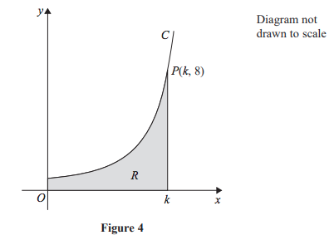
Figure 4 shows a sketch of part of the curve C with parametric equations
x=3θ sin θ $y=\sec^{3}θ$ $0≤θ<\frac{π}{2}$
The point Pk,8lies on C, where $k$is a constant.
It can be shown that $k=\frac{\sqrt{3}}{2}π$
The finite region R, shown shaded in Figure 4, is bounded by the curve C, the $y$-axis, the $x$-axis and the line with equation x=k.
Show that the area of R can be expressed in the form
$λ\int_{α}^{β}{\left(θ\sec^{2}θ+ tan θ\sec^{2}θ\right)dθ}$
where $λ$, $α$ and $β$ are constants to be determined.
Correct answer:
λ=3, α=0, $β=\frac{π}{3}$
Their answer:
λ=3, α=0, $β=\frac{π}{3}$
(4 marks)

Question 20
[Edexcel C4 June 2017 Q8a]
Figure 4 shows a sketch of part of the curve C with parametric equations
x=3θ sin θ $y=\sec^{3}θ$ $0≤θ<\frac{π}{2}$
The point Pk,8lies on C, where $k$is a constant.
Find the exact value of $k$.
Correct answer:
$k=\frac{\sqrt{3}}{2}π$
Their answer:
$k=\frac{\sqrt{3}}{2}π$
(2 marks)

